Medical grade LED light therapy (non-uv)
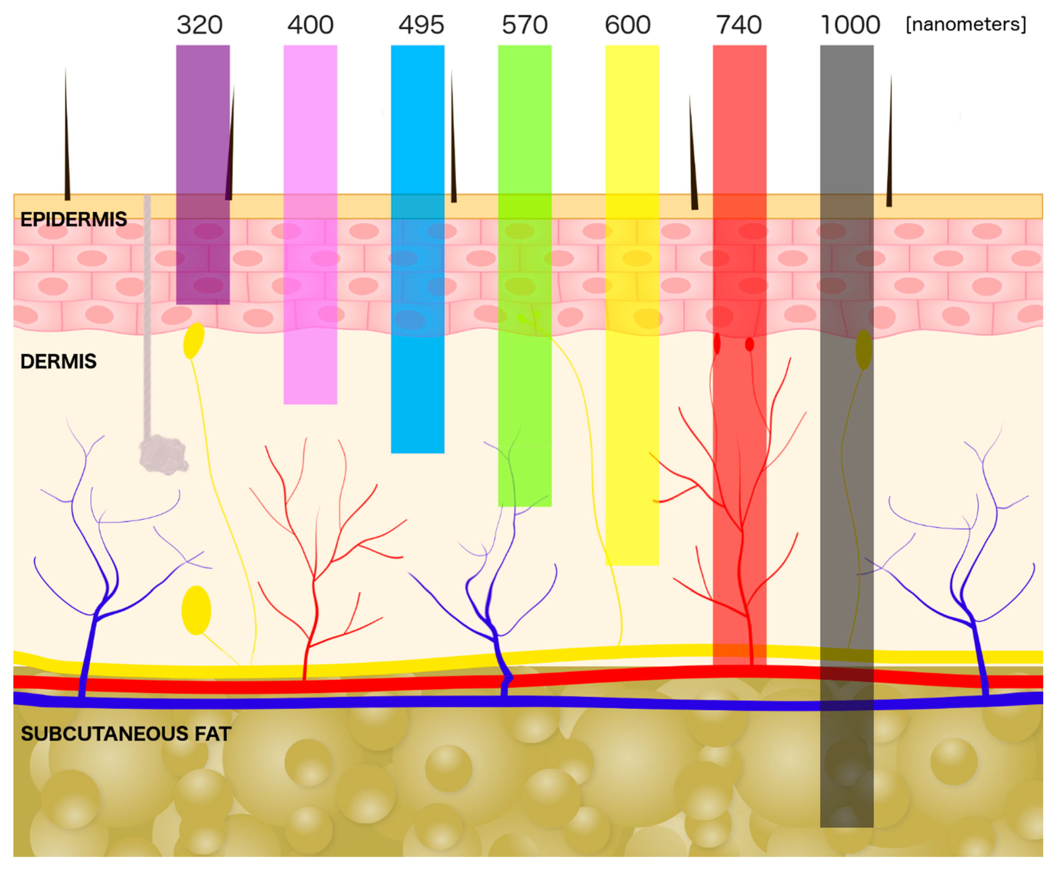

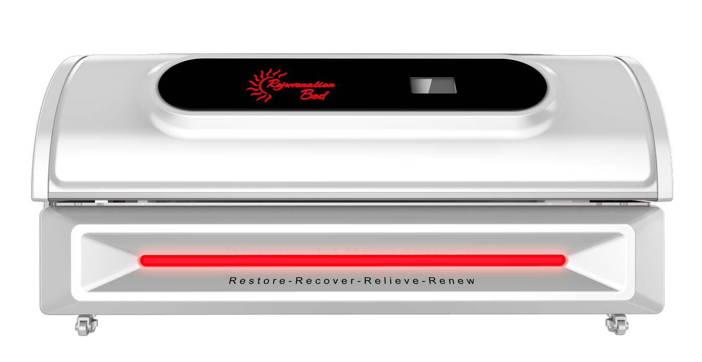

Redlight / Infrared Treatments
10-15 minute Treatments - Recommended 2-3 times weekly for 2 to 3 months for max repair/effects
Maintenance: 1-2 times/week or as needed (1st session approx. 10 min.) increase if desired)
Monthly EFT (3 mo. min) $149/mo.
Monthly EFT (3 mo. min) dis. $129/mo. (if you have both active tanning and Rejuvenation eft
30 days $179
15 sessions: $375
10 sessions: $289
Single Session: $35
(Specific protective eyewear required) (not recommended for pregnant women) (remove metal objects)

Discover Clincally Proven Red Light Benefits

Increases Blood Circulation Boosts Immune System Hair Growth Weight Loss Muscle Recovery Reduces Fatigue Stimulates Collagen Relieve Pain
Sports Injury Repair Anti-aging Boosts Mood Enhances Energy Levels Eases Pain Soothes Inflammation Promotes Sleep Quality Optimize Brain Function Reduces Acne and Scars Improves Joint Health

